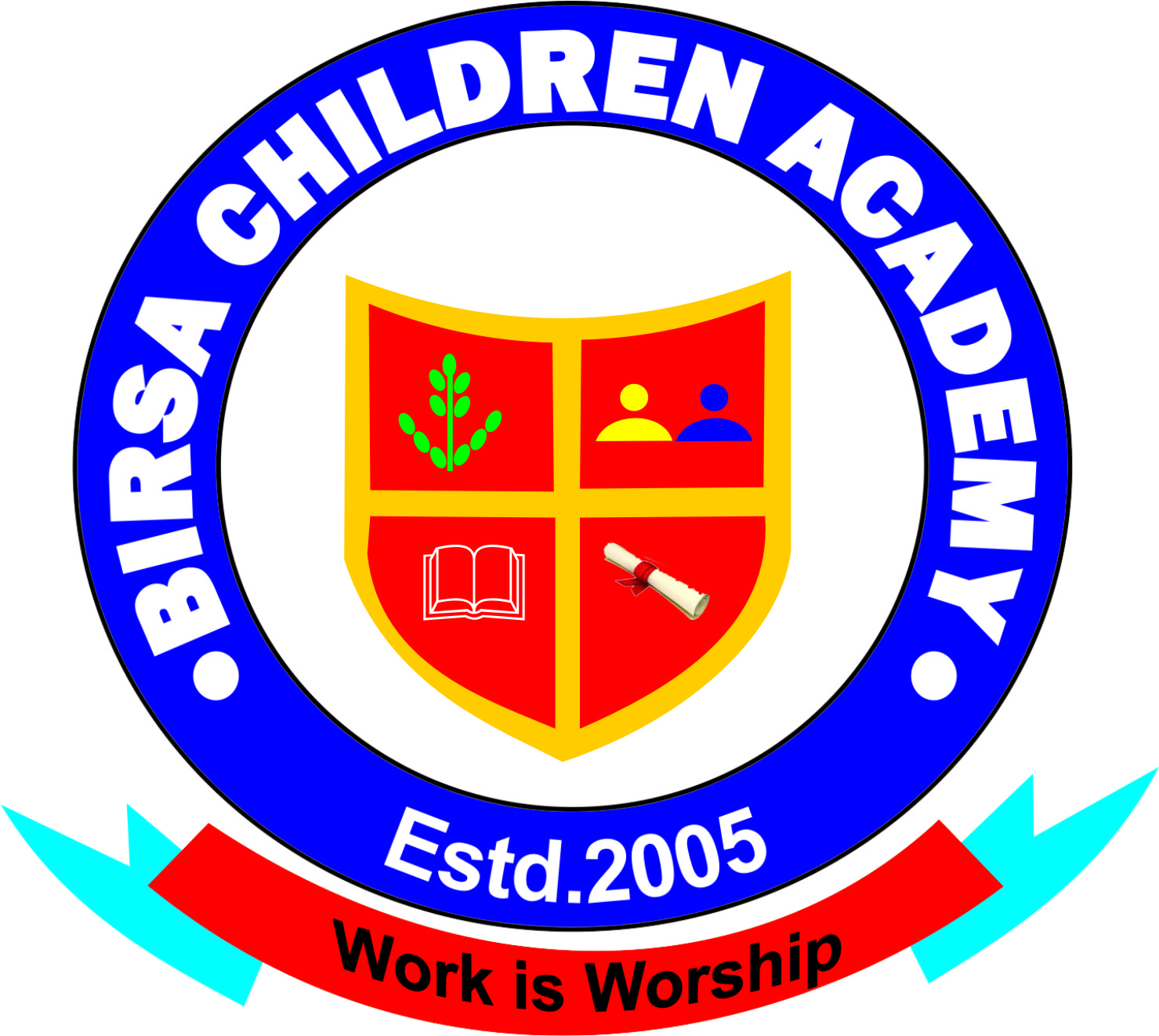
BIRSA CHILDREN ACADEMY
An Anglo – Vedic School Bundu
Managed By – Birsa Social Welfare Academy (Recognized by Govt. of Jharkhand)

ADMISSION FORM
S.N…………..
1. Name of student (Capital Letter)…………………………………………………………………………………..
2. Father’s Name……………………………………………………………………………………………………………… Recent Passport
3. Father’s Qualification / Occupation…………………………………………………………………………….. Size Photograph
4. Mother’s Name……………………………………………………………………………………………………………..
5. Mother’s Qualification / Occupation ………………………………………………………………………………………………
6. Address (correspondence) :- Vill …………………………………………………….. ……………….. PO………………………
PS………………………………….. Dist……………………….. PIN ……………………………… Phone…………………..……………
7. Address ( Permanent ):- Vill …………………………………………………….. ……………….. PO………………………
PS………………………………….. Dist……………………….. PIN ……………………………… Phone…………………..……………
8. Religion …………………….…. Cast …………………….. Category……….……………… Sex …………………………………..
9. Date of Birth ………………………………………… (In words )…………………………………………………………………………….
10. Class in which He/ She wants to be Admitted…………………………..…………………………………………………………
11. Class in which He /She was reading in previous school ……………………………………………………………………..
12. Name of the School from where He / She comes……………………………………………………………………………….
Place :-
Sign of Guardian/ Parent
Date :-

( For Office Use Only )
Name ……………………………………………………………………………………………….. Date …………………………..
Class ………………………………………………. Roll No………………………………………
Admitted / Not Admitted ………………………………………………………………………
Date of Admission …………………………………………………………………………………

Accountant’s Sign Principal’s Sign

